Name: _______________________________________________________________________________________ Date:______________________________ Period:______________

Use the textbook maps and charts to complete the following information. Utilize the maps at the beginning of the unit.
Country | Population Density | Climate(s) | Natural Resources/Land Use | Major cities or centers of manufacturing | Major bodies of water, rivers, seas, etc
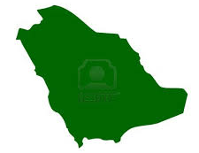
Saudi Arabia
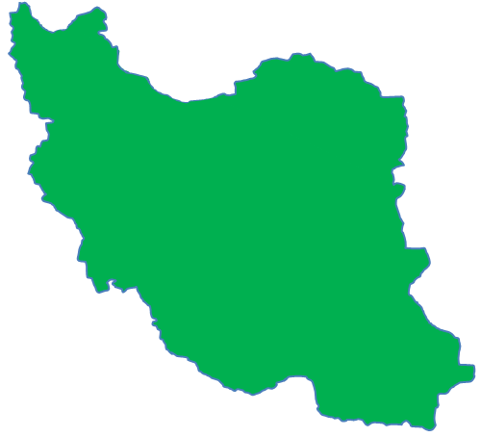
Iran
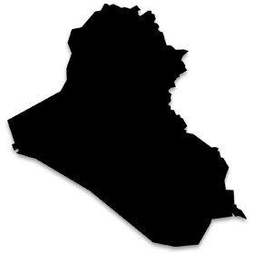
Iraq
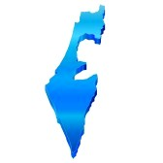
Israel
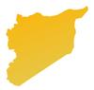
Syria
Egypt
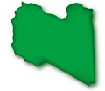
Libya
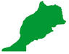
Morocco

- Which of the countries have the best mixture of non-renewable or strategic minerals?

- Describe the dominant climate of the region?

- Which country has the most major cities or centers of manufacturing?
- What countries have oil play as a resource for the region?

- What role does oil play as a resource for the region?

- What roles does the Nile River play in Egypt?

- What cities are located as major shipping ports?

